Playing the piano |  |  |  |  |  |  |  |   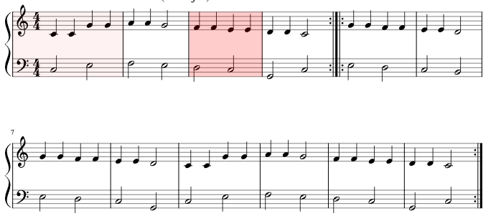 |  | Since January 2023 I have been playing the piano quite a bit and have learnt a fair few songs and I love to play them. It takes my mind of things. It helps my anxiety and lifts me up. I play before I go to work for a short while, gets me in the zone.  Nearly every piano piece I hear played by someone I like. I think it’s a really nice instrument.  I have learnt classical pieces like the Blue Danube, Hungarian dance no 5 and also some intros of Linkin Park songs (one of my favourite bands). I have started learning the main soundtrack of the Lord of the Rings movies as well.  Learning a relaxing piano piece that I found on YouTube.
Playing the guitar |  |  |  |  |  |  |  | 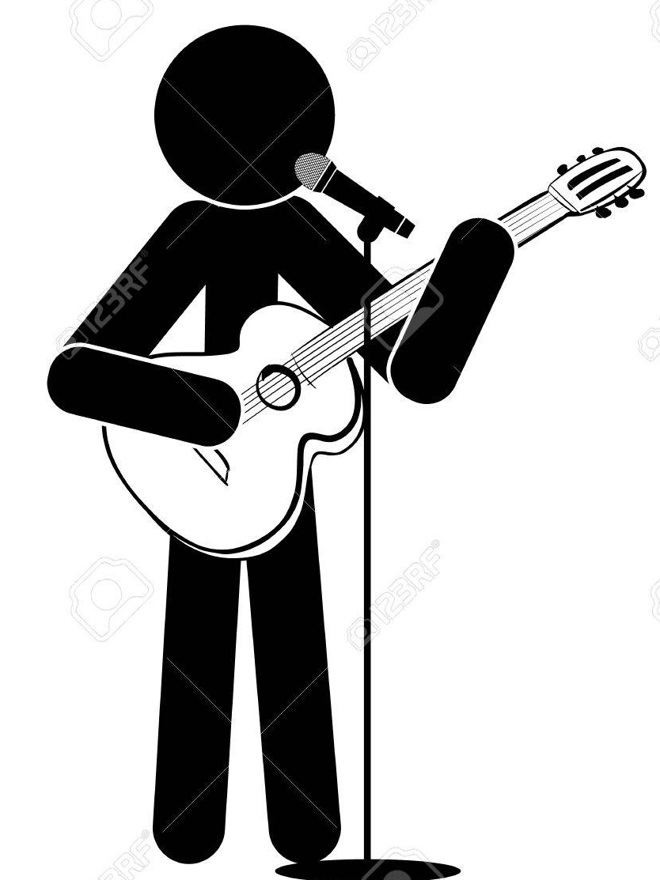  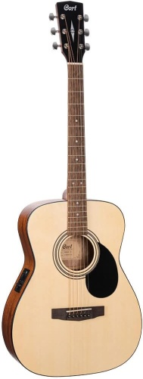  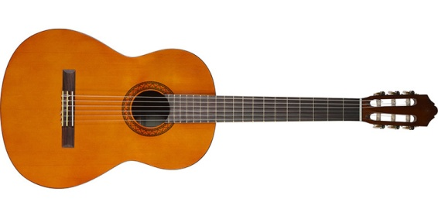 |  | Learning new songs and getting better at existing ones is great fun. I have been playing guitar for a while but since early 2023 I have been playing more regularly.  I have learnt how to play: hero of war, roadside, swing life away , the road I must travel, iris , second chance, mr Brightside, ,  Made my own spanishy sounding guitar tune  Since June 24, started playing tabs of classical pieces. Have a found good website for getting tabs.
Playing the ukulele! |  |  |  |  |  |  |  | 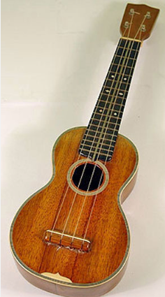 |  | I bought this recently in May 2025, and I can play the Super Mario theme tune and the Harry Potter theme tune!  It was also fun playing chords and singing boulevard of broken dreams by Green Day.
Collecting and looking at scenic photos |  |  |  |  |  |  |  | 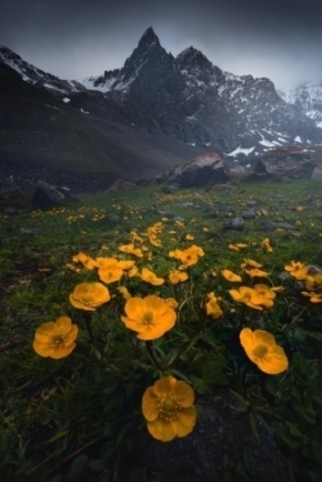 |  | I love collecting things, and one of my most recent ideas has been to collect amazing photographs. Lots of them come from reddit.  They are good for mindfulness. I can stare at them from long periods and admire what the photographs show.  Got a lot more photos this year (2024).
Walking  (shorter <1 hour trips) | Local woods |  |  |  |  |  |  | 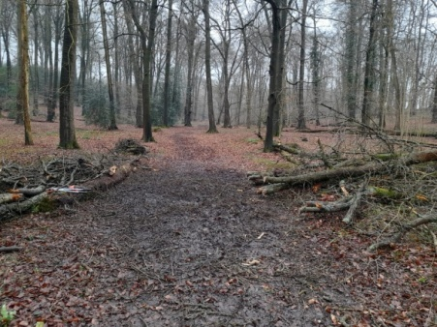 |  | I try to get out at least once a day as I do notice a difference in energy levels, anxiety and mood.  Other times I will go out on a hiking adventure for a few hours (see below).
Walking  (shorter <1 hour trips) | Local common
Walking (Longer ones) | River Chess to Chesham |  |  |  |  |  |  | 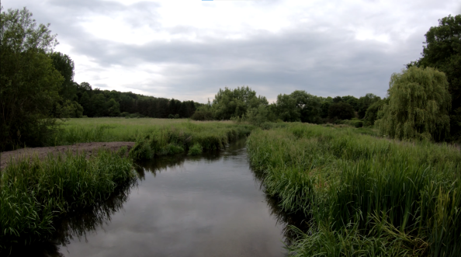 |  | I love doing long distances when I can. I feel like hiking allows me to work through problems clearer and I love seeing the world go by. I take in my sights as I walk along, trying to be mindful.  Other times I like to listen to my podcasts on my phone that I download from YouTube and listen to music as well. Going for a long time gives me plenty of time to listen to these.
Walking (Longer ones) | River Misbourne to Amersham
Walking (Longer ones) | Grand union Canal / Aquadrome
Walking (Longer ones) | Walking with dad to my favourite pub to get alcohol free beer and food |  |  |  |  |  |  | 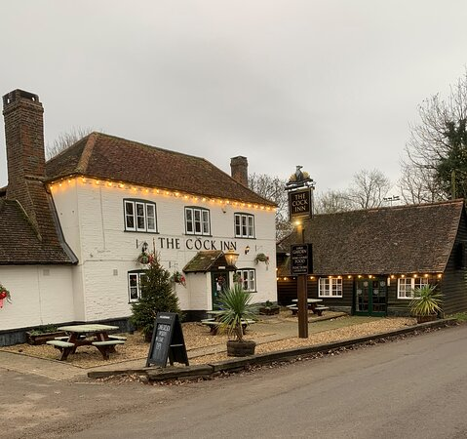 |  | Visiting pubs on a walk makes it more of a memorable trip for me. I have an alcohol free beer. Pubs are very social places, often looks nice and have a great atmosphere.  I don’t feel bad having alcohol free drinks.
Planning new walking routes in the South of England on the Komoot app – for me to go on new adventures |  |  |  |  |  |  |  | 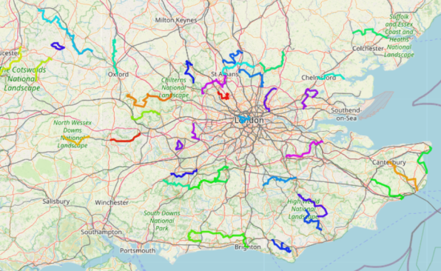 |  | I can use the Komoot app on the phone or computer.  It’s nice to look at this interactive map of the hikes that I’ve planned.
Working on my hiking website |  |  |  |  |  |  |  | 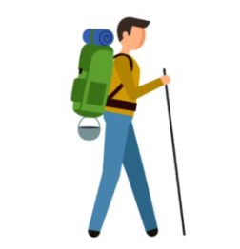 |  | Writing info of each hike, adding photos and improving the look of the website.
Editing scenery videos for my YouTube channel |  |  |  |  |  |  |  | 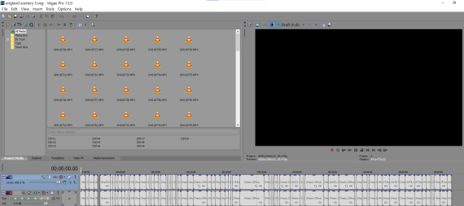 |  | I’ve read being creative is good for mental health, and I like to do video editing of my videography and photography in time with music. I feel like its a bit of a jigsaw getting everything to work out but enjoy the process and the end result.
Photography / Videography |  |  |  |  |  |  |  | 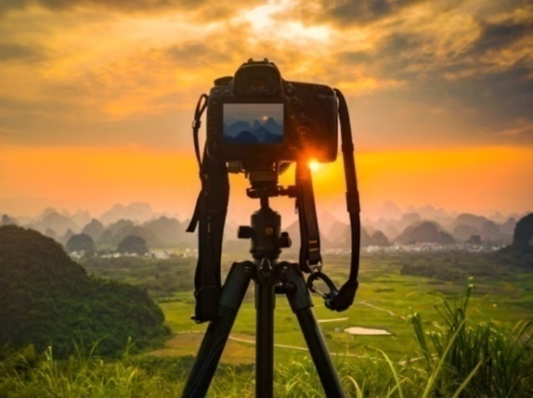 |  | I feel photography got me to appreciate the world around me more. I see the beauty in what’s around me now even when I haven’t got cameras and often looking at my surroundings  I like to film my walks. Take pictures of animals.  When on holidays I find photography motivates me to see as much as possible.
Breathing meditations in nature |  |  |  |  |  |  |  | 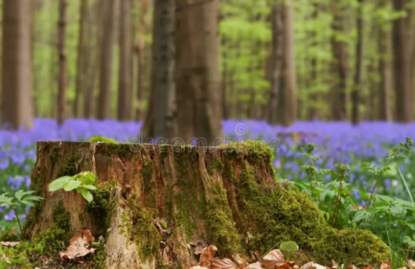  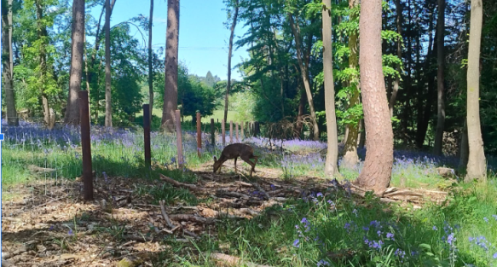 |  | I like to go to the local woods and sit on a tree stump that’s a bit off a quiet path in the local woods. With guided breathing meditations on my phone on repeat. Or just meditational music. Very relaxing.  Could also do in the garden.  Had a deer walk right past me while I was in my usual spot meditating (pictured).
Meditations (at home) |  |  |  |  |  |  |  | 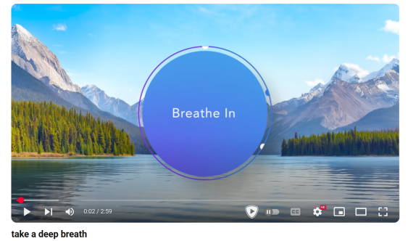   |  | There’s this really good guided meditation YouTube channel called ‘CALM’.  There are also Leaves on a stream, letting go, being present. Sleep meditations.  I do these when I’m anxious, or if I’m ever ruminating about things.  Can even do in car with CD that has meditational music
Reading | Lord of the Rings books |  |  |  |  |  |  | 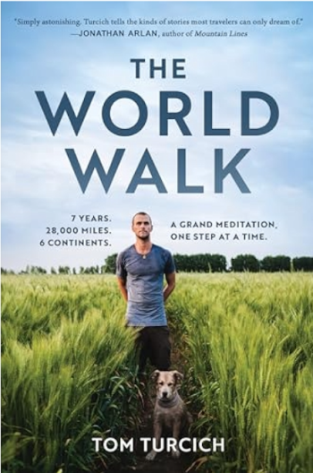  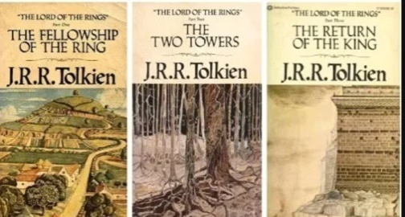 |  | I’ve read all the Harry Potter books, the Narnia books in the last few years. I’m on the final Lord of the Rings book.  Can get books from car boot sales and charity shops.  I find it easier to read at the library, less distractions. Sometimes I will read on my walks. Sit on a park bench and do a bit of reading.
Reading | The World Walk
Reading | Harry Potter books
Reading | Narnia books
Reading | Animal / wildlife books
Reading | History books
Creative novel writing |  |  |  |  |  |  |  | 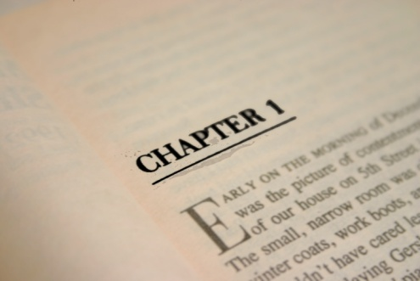 |  | Just started doing this for fun. Found it really enjoyable writing ideas of stories down. I would love to make a good fantasy book one day. I’ve got two books I’m working on.
Listening to audiobooks and YouTube podcasts downloaded onto phone  (Can listen to them on walks or while sitting down). |  |  |  |  |  |  |  |  |  | Animals, space and hypothetical situations, survival stories, self care tips, interviews with people I look up too. Historical events.
Talking to my family |  |  |  |  |  |  |  |  |  | I find social interaction and talking lifts me up. Gets my brain working and I feel more upbeat after a nice conversation.
Adult colouring books |  |  |  |  |  |  |  |  |  | Might sound ridiculous but I find these very relaxing and helpful for my anxiety.  When I do these books I listen to relaxing piano music with birds singing on YouTube at the same time.  I bought some of these books from a charity shop and bought a load of pens from Amazon.
Mind mental health online virtual meeting places |  |  |  |  |  |  |  |  |  | Very good. Easy to talk to people. No judgement there.  Saturday: 11 AM -1pm  Tuesday: after work 6:30 – 8:30pm
Looking at my photobooks (that I ordered online)  & creating more ones! |  |  |  |  |  |  |  | 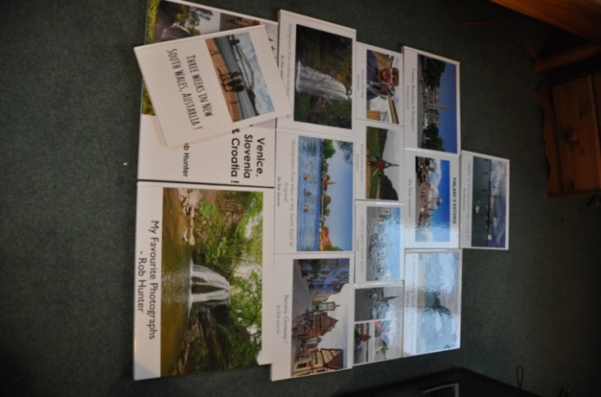 |  | I’ve made quite a few of these. I love looking at all the photographs I’ve taken and also nice to see them in a book rather than through a screen  www.photobox.co.uk is a good website. The prints always look good.  I used doxzoo.com to print a diary of a three week trip to Australia (with photos).
Running |  |  |  |  |  |  |  |  | 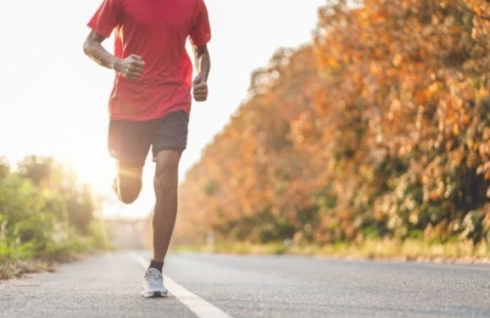 | Last year (2023) I did a bit of running. Going to try to get back into it again but being careful so I don’t get shin issues again.  I hope to be able to get into long distance running.
Board games |  | Bannagram |  |  |  |  |  |  | 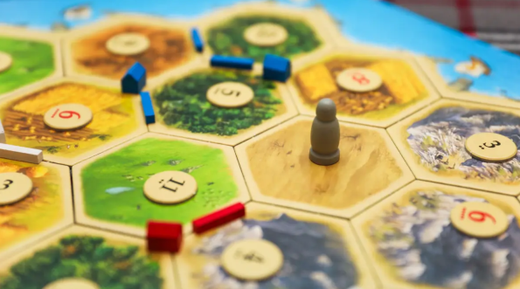  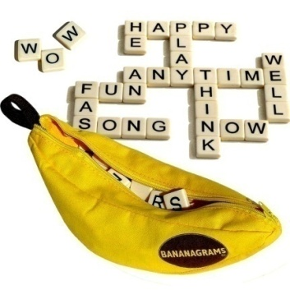 | I feel board games are very enjoyable – not just the games but the social side of playing with friends or whoever.  I use to do these with two friends that I met. R.I.P Mike.  Also play with my parents from time to time.  Can go to a meetup at Watford board games cafe or with Chesham Mind.
 |  | Scrabble
 |  | Sagrada
 |  | Chess
 |  | Settlers
 |  | Risk
Cards |  |  |  |  |  |  |  |  | 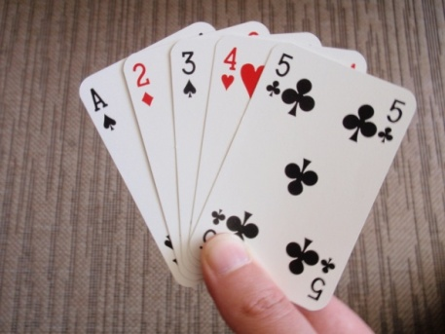 | I like to play card games with my parents. Change it with Ace, Hearts, Euchre.
Looking up quotes on Facebook or online and writing them down in diary / phone |  |  |  |  |  |  |  |  | 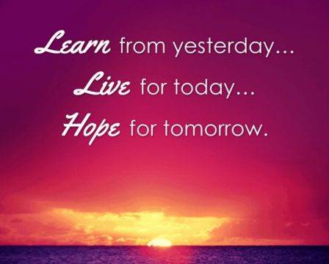 | Eg.. Learn from yesterday. Live for Today. Hope for tomorrow.  They did not know it was impossible, so they did it.  The quieter you become the more you hear.
Listening to music |  |  |  |  |  |  |  |  | 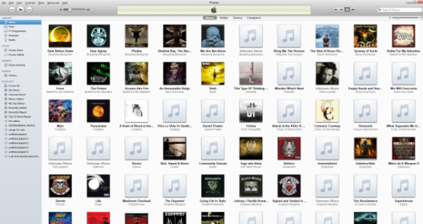 | I often listen to music while relaxing at home.  I like quite a few genres, which is nice as if I get fed up of one genre I can move to another.
Searching for new music |  |  |  |  |  |  |  |  |  | I use to really love doing this in school looking for new music. I’ve done it a fair bit recently. Love it when I find good new music. Music is a big passion of mine.  Can search specific bands you like or just new music per calendar year. Or use Spotify recommendations.
Allotment |  |  |  |  | Watering |  |  |  | 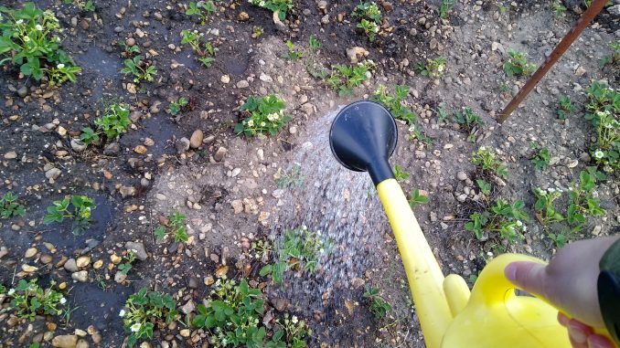 | I’ve read doing gardening is good for mental health, watering is also helpful for my back. Lifting stuff helps build my back muscles which is helpful as I injured my back a few years ago.
 |  |  |  |  | Picking up veg / fruit from allotment |  |  |  | 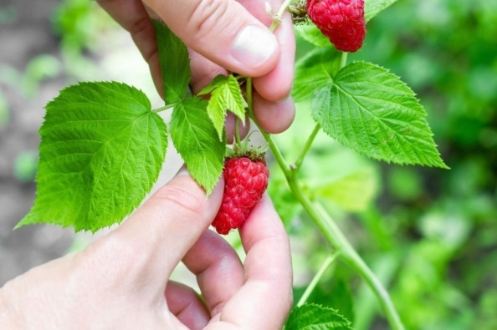 | The most rewarding thing is eating something you’ve helped grow.
 |  |  |  |  | Digging |  |  |  |  | Digging helps build core strength. I feel like working with plants completely takes my mind off things as well and find it easy to be mindful when I’m at the allotment / gardening.
Gardening at home |  |  |  |  | Raking leaves |  |  |  | 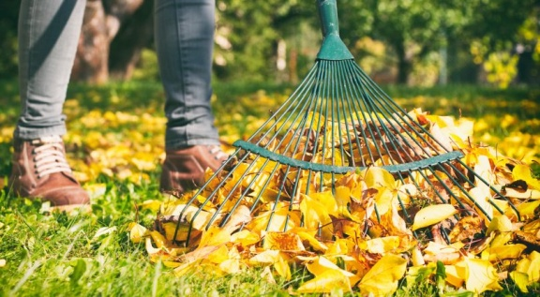 | You can see the progress of your work and its outdoors.
 |  |  |  |  | Trimming gardening |  |  |  | 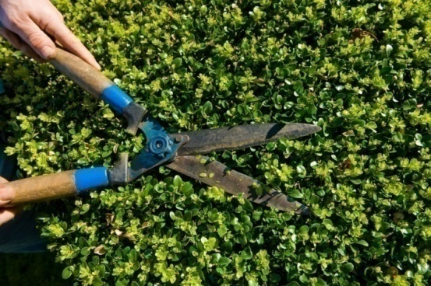 | My mum asked me to do this a few years back and I actually found it very enjoyable. Nice to see the progress.
Puzzles |  |  |  |  |  |  |  |  |  | I prefer the jigsaws with not as many pieces as they don’t take as long and you can do them in one sitting.  I have a world map one that I’d like to. Holly from my work gave me a few animal jigsaws that I can try
Writing diaries and reading the multiple diaries I’ve wrote in |  |  |  |  |  |  |  |  | 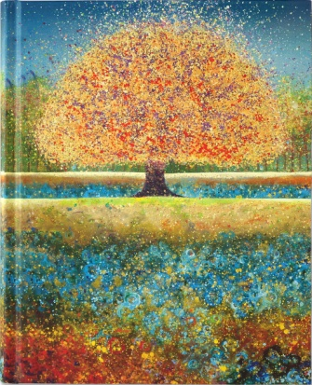 | Very nice to read all the positive moments!  Nice to see your progress.  And I like to do CBT with myself and i find it effective for me work through my problems / worries.  I’ve started doing diaries again in 2025.
Camping in my bivvy bag or new tent |  |  |  |  |  |  |  |  | 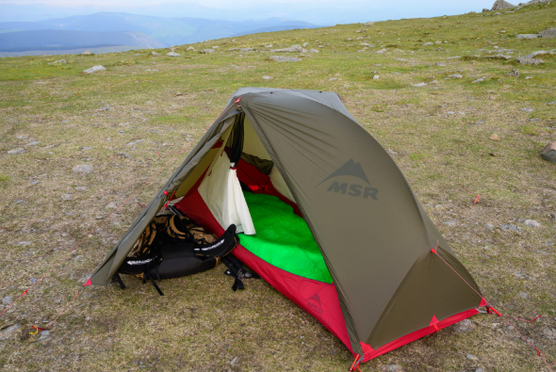 | The bivvy bag is cool if you want to see the sky just unzip the zip. It’s very lightweight so I can sleep pretty much anywhere!  An idea is maybe to go wild camping or go to campsites with dad.
Nintendo DS |  |  |  |  |  | Tetris DS |  |  |  | Very fun. I feel I’m good at this game. Sometimes i beat my brother when I play it. Sometimes it’s the other way around!
 |  |  |  |  |  | Mario kart Ds |  |  |  | Pretty good game. I’m getting better at drifting which is nice.
 |  |  |  |  |  | Super Mario Bros DS |  |  |  | Great game!
Playing my steam deck – playing all the PC games on a handheld console. |  |  |  |  |  |  |  |  |  | An amazing portable console!  Can play all the Halo games, Skyrim etc which I really use to enjoy playing. Can watch movies on there and its 500gb.
Nintendo Wii console |  |  |  |  |  |  |  |  |  | Have four games on there (Mario Kart, Medal of Honour, New Super Mario Bros, and Super Smash Bros Brawl!)
TV shows |  |  |  |  |  | Lord of the Rings TV show |  |  | 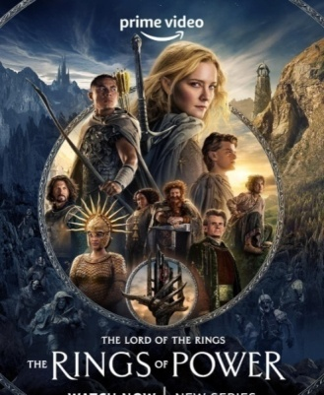 | Absolutely brilliant show. Not as good as the original trilogy but still really good in my view. Gets better as it goes on.
 |  |  |  |  |  | Robin hood TV show |  |  | 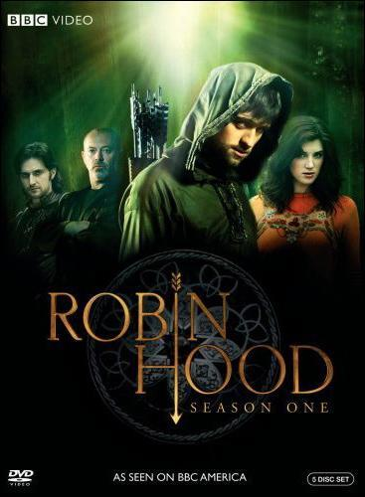 | Quite an old one from 2006, it was my favourite tv show in school. I watched series 1 recently, need to watch the next two now.
Going to Mexica - the Chinese buffet restaurant in Rickmansworth |  |  |  |  |  |  |  |  | 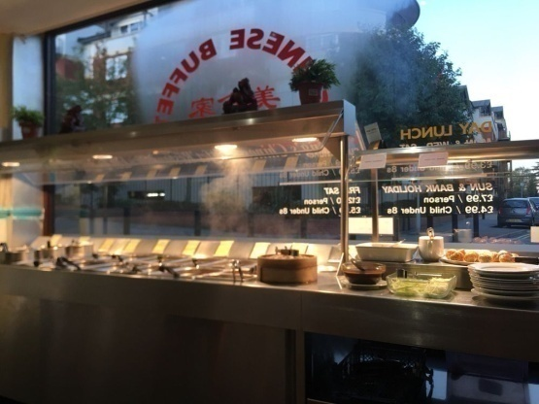 | There’s a local Chinese buffet to me that’s my favourite eating out place.  £11 for dinner  Cheaper for lunch
Table tennis |  |  |  |  |  |  |  |  |  | This summer (2022) I have played table tennis with my brother a few times outside. It is fun. I feel like I’m quite good at it.  There’s a local club in Chalfont St Peter that I’ve been to. & I use to go to a table tennis session organised by my previous mental health team.
YouTube |  |  |  |  |  |  | Watching scenery videos on YouTube |  |  | The “Scenic relaxation” YouTube channel is my favourite one of these. They have great drone footage of different countries with relaxing music.
 |  |  |  |  |  |  | Watching animal videos |  |  | The Dodo and Furry Tails post great videos.  Reddit subreddits are cool for looking at animal videos.
Interpals |  |  |  |  |  |  |  |  |  | Had a few interesting conversations on them over the years. Like Leysan from Russia  You can make penpals from all over the world. Could try talking to new people if you’re ever not sure what to do.
Watching football |  |  |  |  |  |  |  |  |  | I have found it relaxing before watching it. And very enjoyable during world cups and Euros. .  World cup 2026 next year.
Meetups |  |  |  | Chiltern Young Walkers |  |  |  |  |    | Mental health mates is a great one. Everyone’s alright that goes.  Table tennis meet up Sunday at 10:30 to 12:30  Chiltern Young Walkers - great meetup  Bucks mind board games: 12pm to 3pm Thursday  2:30pm to 4:30pm Saturday  There’s also metropolitan walkers (that do walks in London)
 |  |  |  | Table tennis meet up club
 |  |  |  | Mental health mates
 |  |  |  | Bucks mind board games meetup
Walking my neighbours dog |  |  |  |  |  |  |  |  | 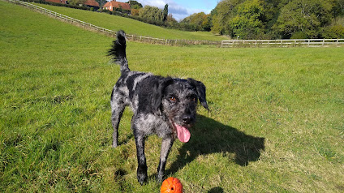 | Could always bring him to our house sometime to play fetch in garden or take him to the local river.
Swimming |  |  |  |  |  |  |  |  | 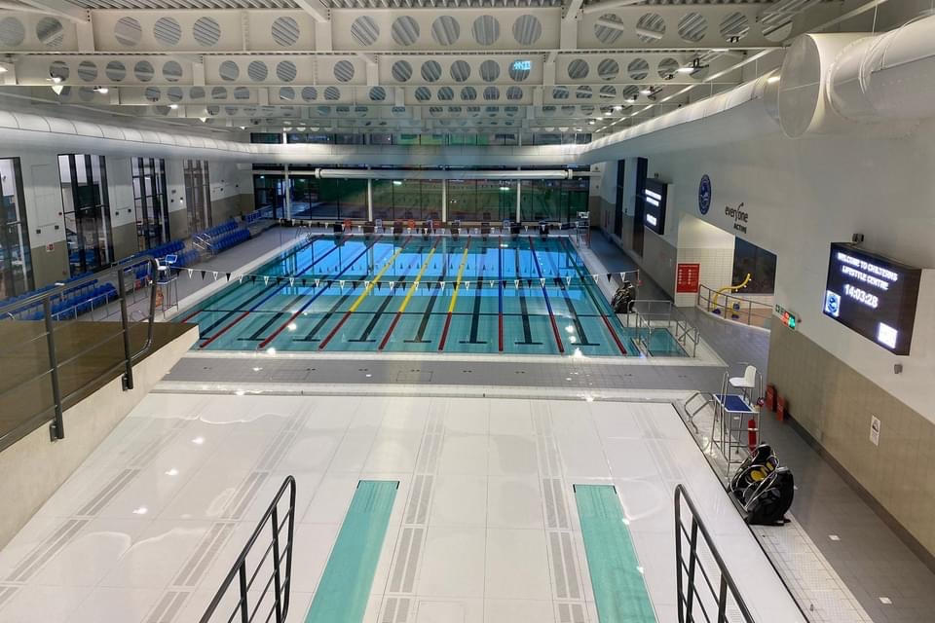 | £6.75 PER SESSION  Amersham swimming pool can pay per session. Whereas most swimming pools require you to have a membership.
Car boot sales |  |  |  |  |  |  |  |  | 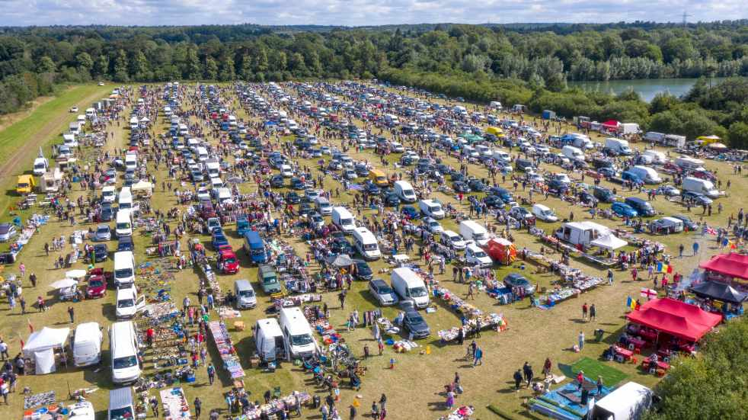 | Good to do now that I have weekends off  Get some bargains. An experience just going there even if you don’t buy something. Often see my friend from school Luke selling things there.
Browsing charity shops |  |  |  |  |  |  |  |  | 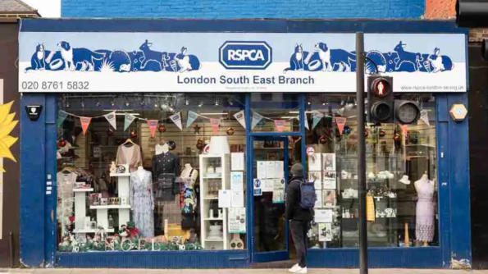 | In different towns that are close to me. When I go on long walks to different towns I try to visit the charity shops there.  Jigsaws, paintings, books etc,
Sunbathing / Sitting on benches outside |  |  |  |  |  |  |  |  |  | You get vitamin D, feels nice on your skin and good for relaxation.
Movies |  |  | Animated – Ice Age, Lion King, Toy Story & other Disney movies |  |  |  |  |  |  | Great with salted popcorn (that I like to make myself)  Can watch downstairs on big screen, phone or on computer.
 |  |  | Comedies - Blue Streak, Rush Hour, Mr Beans Holiday |  |  |  |  |  | 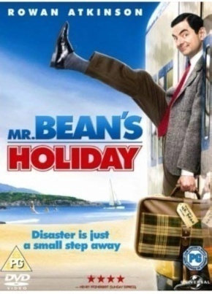
 |  |  | Fantasy - Lord of the Rings movies |  |  |  |  |  | 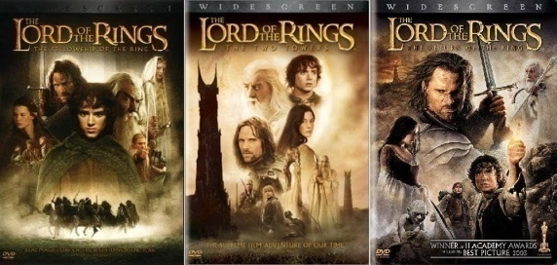
 |  |  | Marvel / DC movies |  |  |  |  |  | 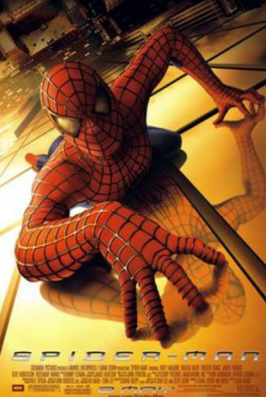
Cooking |  |  |  |  |  |  |  |  |  | Rice, chicken breast, onions, garlic broccoli, carrots, ginger, with soy sauce  Eggs Benedict – smoke salmon and scrambled eggs.  I like to do cooking listening to music.
Going on day trips in the car |  |  |  | Southend |  |  |  |  | 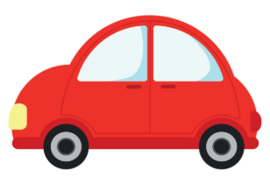 | Love going out, a change of scenery. These are the most common places me and my parents tend to go.
 |  |  |  | Black Park
Marlow
(River Thames)
Going  to museums and zoos |  |  |  | Natural History museum |  |  |  |  | 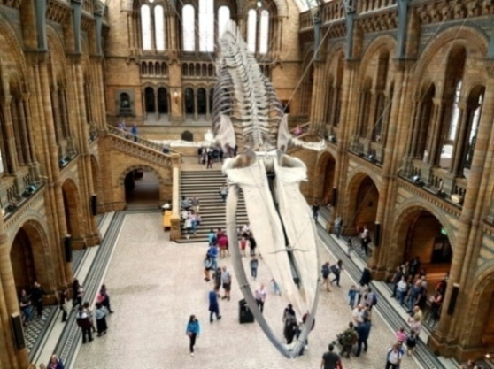 | I’ve got a huge list of different zoos and museums to visit.  Mick and Karen say they can get me into London Zoo for free as they work there.  I often go with my father to museums.
 |  |  |  | National Art Gallery
 |  |  |  | London Zoo / Whipsnade
Going to theme parks with my brother |  |  |  |  |  |  |  |  |  | I went to Thorpe Park and on some rides at Winter Wonderland with my brother (2022 and 2023).  Daniel wants to go to Alton Towers with me as well. Possibly this year in 2025!

